Our vision is to create a community based on Catholic faith and values where every child is empowered to be the best he or she can be, nurtured by outstanding teachers, staff and governors

Home Learning Policy 2023 - 2024

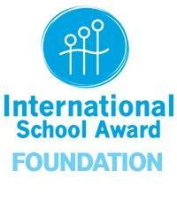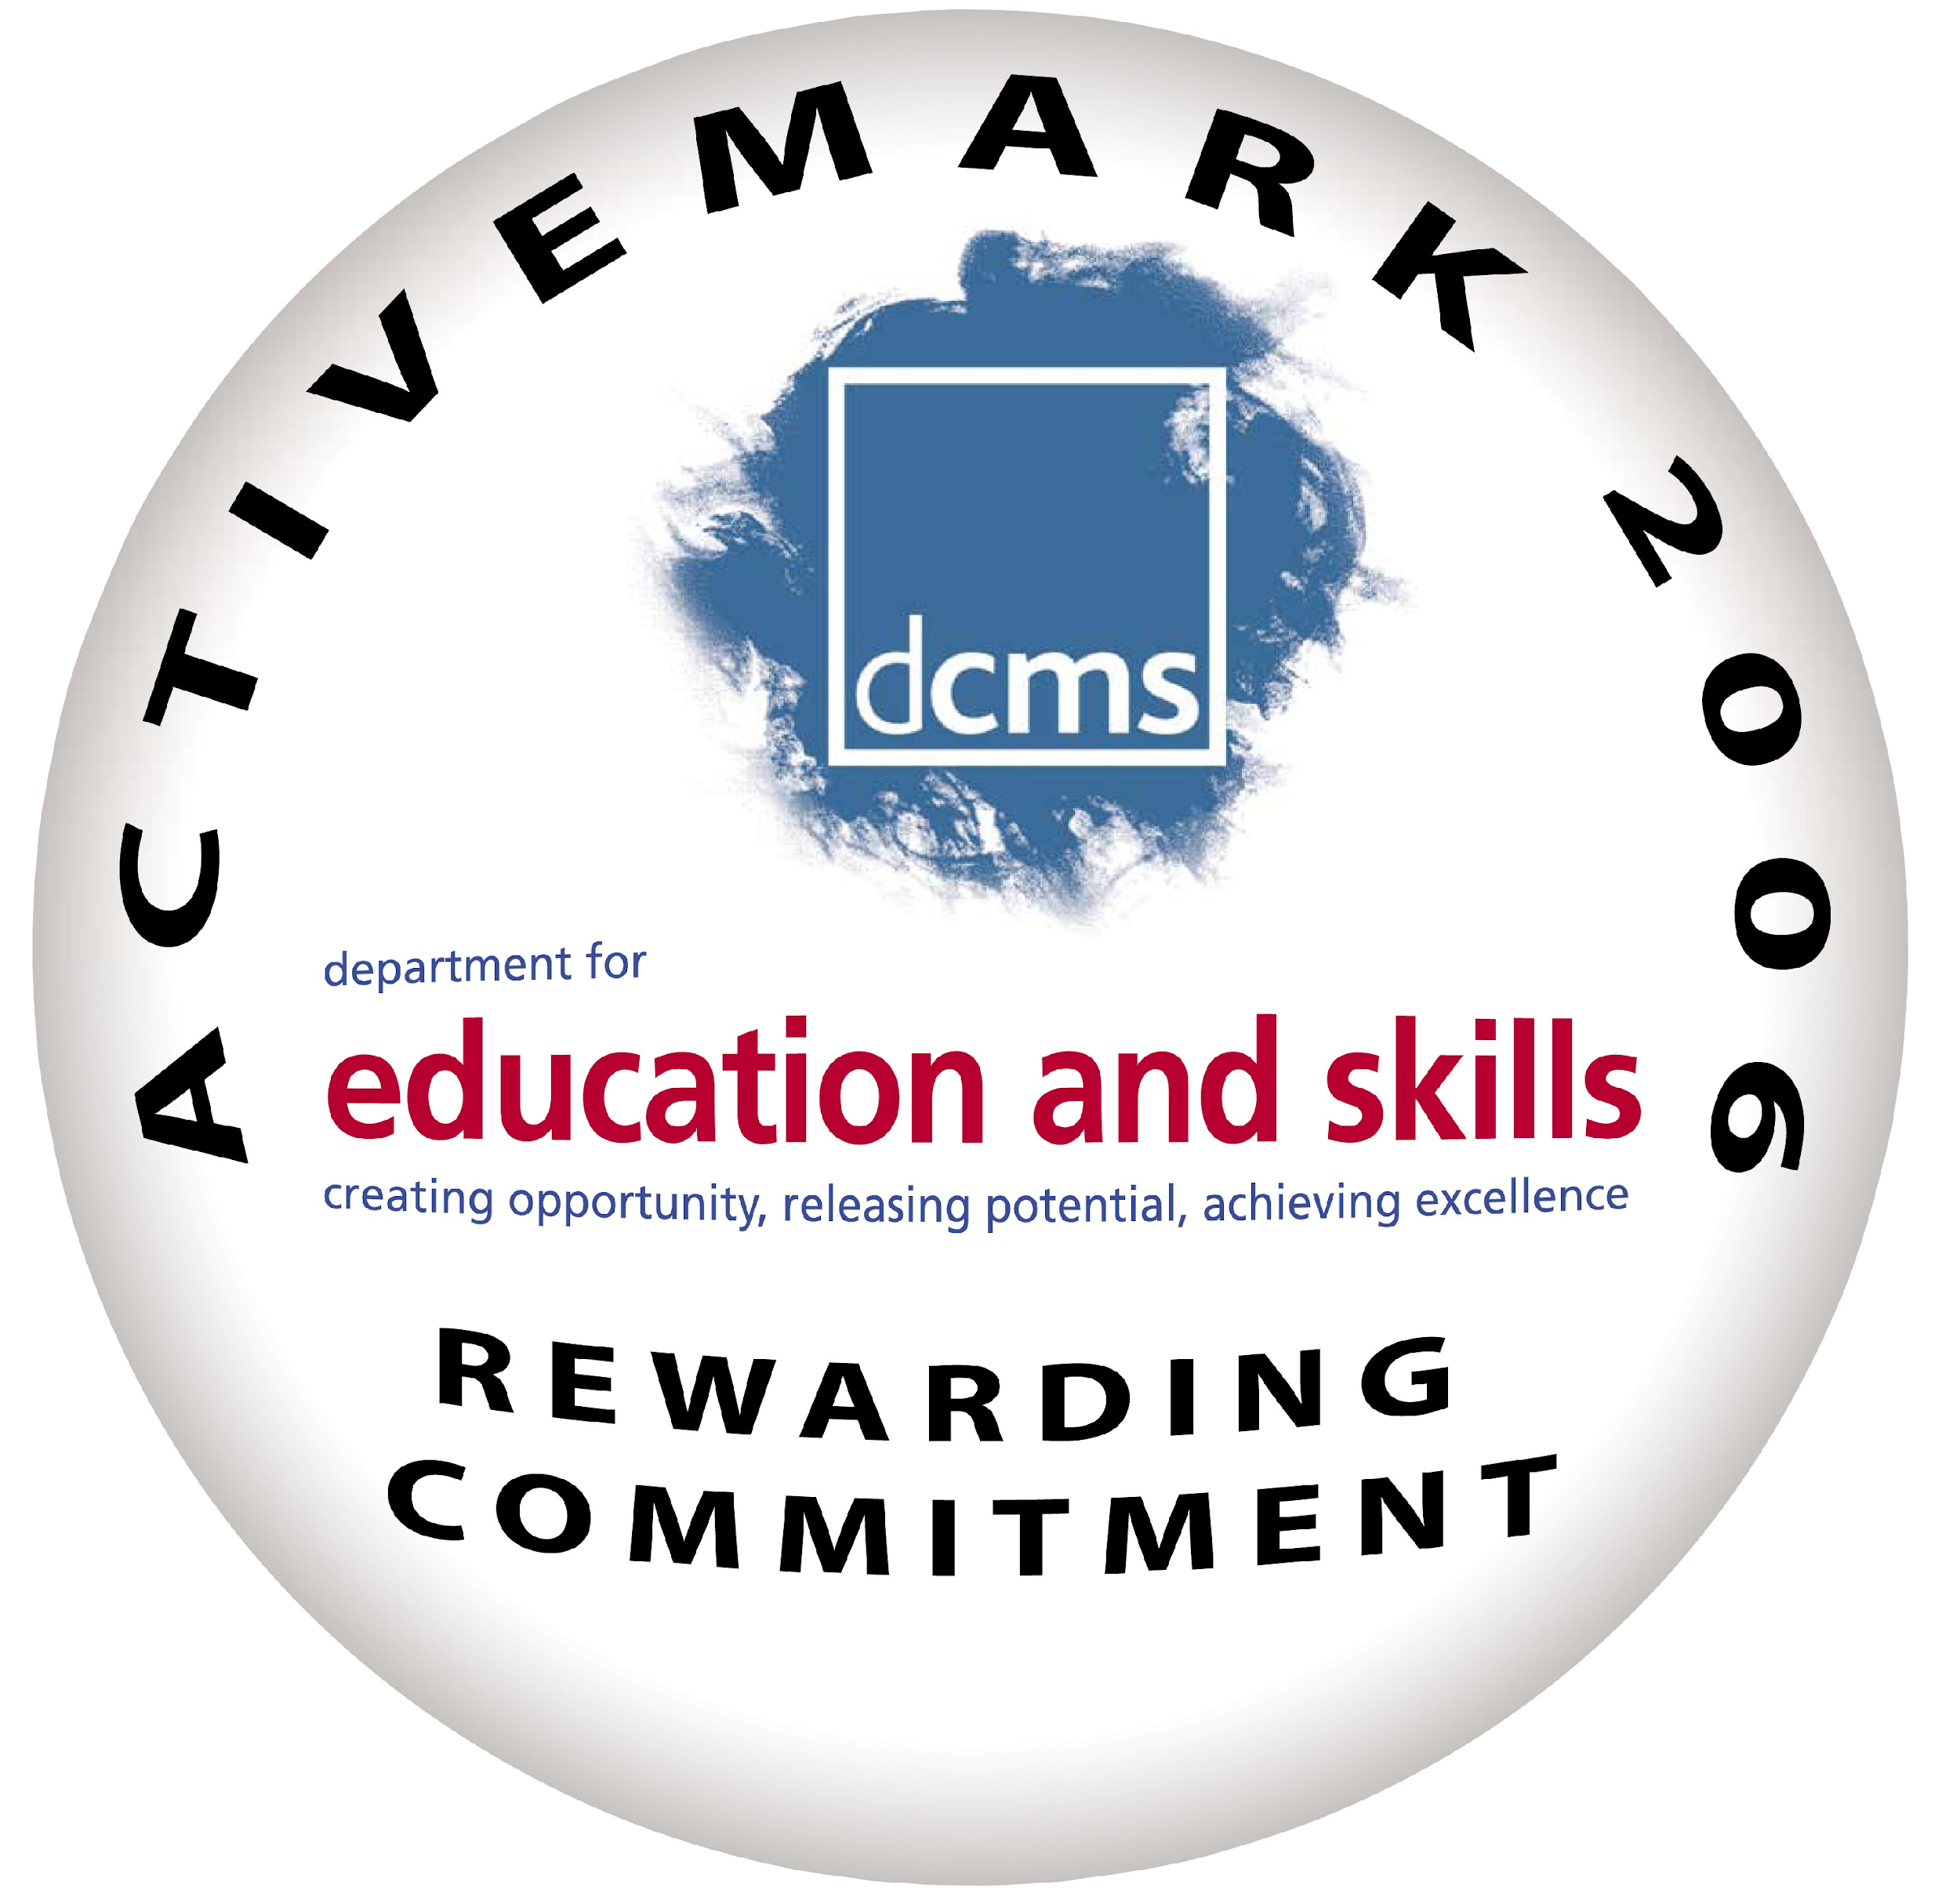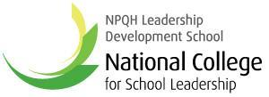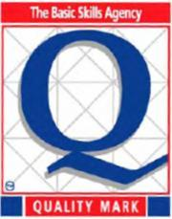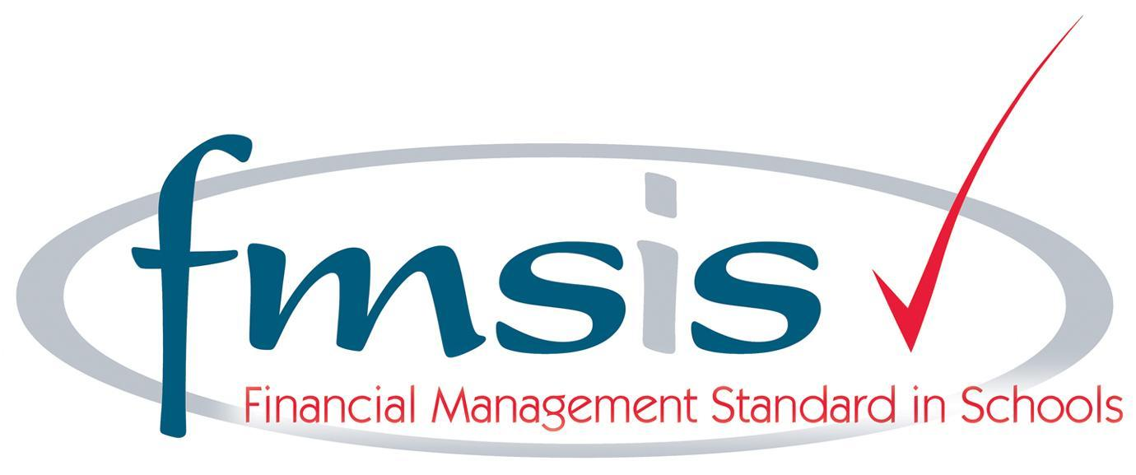

St Martha’s Catholic Primary School
Home Learning Policy

Aims

- It is an expectation that all children will carry on learning at home and that all teachers set home learning tasks;
- The purpose of home learning is to consolidate and extend the learning of our pupils;
- Learning at home is highly valued by teaching staff. Children will receive regular rewards and feedback on their home learning.

Methodology

Specific home learning tasks will vary according to the age and needs of each child.

Pupils will be set home learning within the following framework:

In EYFS children will receive:

- A weekly guided reading book once a range of sounds have been taught. This reading should be recorded by an adult in the child’s reading record.
- Fortnightly ‘tricky/ high frequency words’ flashcards,
- A handwriting sheet linked to the phonemes taught,
- Home learning is also carried out through the regular contribution of children’s learning by parents in the children’s Learning Journey.
- A ‘Next Step Foot’ which is differentiated to meet the developing needs of each individual child. This will change and be sent home as the previous target is met.
- An RE task one per half term.
In Year 1 children will receive:

- A guided reading book to read with an adult each week. This reading should be recorded by an adult in the child’s reading record.
- 10 spellings (covering new sounds/tricky words from the week) to practise in a handwriting book each week. The word list should be typed using the appropriate Letter Join font and stuck in the handwriting book. This will begin in the Spring term in most instances.
- A weekly maths task linked to the learning from that week.
- An RE task one per half term.
In Year 2 children will receive:

- A guided reading book to read with an adult each week. This reading should be recorded by an adult in the child’s reading record.
- 10 spellings (covering new sounds/tricky words from the week) to practise in a handwriting book each week. The word list should be typed using the appropriate Letter Join font and stuck in the handwriting book.
- Frequent use of the Times Table Rockstars app, focussed on the tables currently being learnt.
- A short maths task each week linked to learning from the week,
- An RE task one per half term.
In Year 3 children will receive:

- In the autumn term, all children should receive a guided reading book to read with an adult each week. This should continue after the autumn term for children not meeting age-related expectations.
- After this children will have access to the school library or class library at least once a week to choose a book to read daily at home. This reading should be recorded by an adult in the child’s reading record.
- 10 spellings (covering the spelling pattern from the week) to practise in a handwriting book each week. The word list should be typed using the appropriate Letter Join font and stuck in the handwriting book.
- Frequent use of the Times Table Rockstars app, focussed on the tables currently being learnt.
- A short maths task each week linked to learning from the week,
- An RE task one per half term.
In Year 4 children will receive:

- Children will have access to the school library or class library at least once a week to choose a book to read daily at home. This reading should be recorded by an adult in the child’s reading record.
- 10 spellings (covering the spelling pattern from the week) to practise in a handwriting book each week. The word list should be typed using the appropriate Letter Join font and stuck in the handwriting book.
- Frequent use of the Times Table Rockstars app, focussed on the tables currently being learnt.
- A weekly short maths task linked to learning from the week,
- An RE task one per half term.
In Year 5 children will receive:

- Access to the school library or class library at least once a week to choose a book to read daily at home. This reading should be recorded in the child’s reading record.
- A short reading comprehension task each week.
- 10 spellings (covering the spelling pattern from the week) to practise in a handwriting book each week. The word list should be typed using the appropriate Letter Join font and stuck in the handwriting book.
- Frequent use of the Times Table Rockstars app.
- A weekly maths task linked to learning from the week,
- An RE task one per half term.
In Year 6 children will receive:
- Access to the school library or class library at least once a week to choose a book to read daily at home. This reading should be recorded in the child’s homework diary.
- A weekly reading comprehension task.
- 10 spellings (covering the spelling pattern from the week) to practise in a handwriting book each week. The word list should be typed using the appropriate Letter Join font and stuck in the handwriting book.
- Frequent use of the Times Table Rockstars app.
- A weekly maths task linked to learning from the week,
- A weekly arithmetic practice sheet,
- An RE task one per half term.

Other Considerations

- Home learning should be set on Class Dojo. Children from Year 1 to Year 6 should be given an exercise book which to complete their home learning, and a handwriting book to practise their spellings. Children should be given access to any materials they might need to complete their home learning (e.g. stationery). If a child does not have access to an electronic device at home accommodations should be made.
- Home learning should be set by all year groups on Friday and due in the following Wednesday.
- In Key Stage 2, children’s library book choices should be guided by an adult to ensure they are of the appropriate difficulty.
- During half term holidays, children will be asked to read and use Times Table Rockstars. No home learning should be set, except from Year 6 in the spring term to prepare for their end of Key Stage 2 assessments.
- Adaptations should be made for children on the SEND register.
- Home learning can be assessed through self-assessment, peer assessment or by an adult.

Parental Involvement

We anticipate that parents will actively support their child’s out of school learning. The success of any home learning is to a great extent dependent on parental support. This interest and support will inform parents about the type of tasks their children are undertaking. Parental involvement is highly valued and encouraged.

Reviewed by staff: September 2023

